WALL PAINTING RESTORATION ABOUT WOMEN EMPOWERMENT
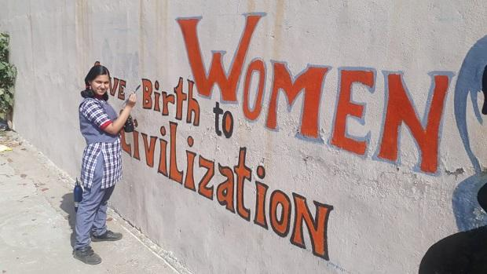

- SAMIKSHA (X-D)

